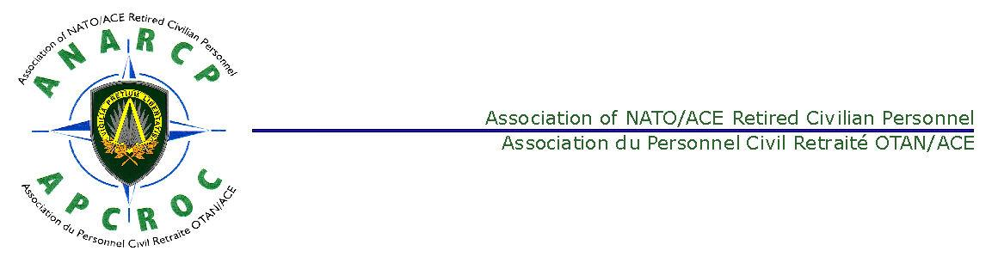
Association of NATO/ACE Retired Civilian Personnel
Association du Personnel Civil Retraite OTAN/ACE
Form Dated: Februray 2016
(An application for ANARCP membership can be made up to one year prior to retirement as a NATO International Civilian)
APPLICATION FOR ANARCP MEMBERSHIP.
Please returned to:
ANARCP (Membership)  HRM Branch  Human Resources Management Directorate  B-7010 - SHAPE Belgium |  | Or  E Mail it to: ANARCP1980@gmail.com
Last Name: | First Name: |  | Mr.. Mrs.. Miss  (Please highlight)
Date of Birth: |  | Mailing address:
Phone Number, including Country Code: |  | E-Mail address:
Country of Permanent Residence:

Qualification for Membership: (Please highlight) for former NATO International Civilians
NATO Insurance Scheme:  Myself  As a dependent  Invalidity pension |  | NATO Pension/Provident/Other*  Retirement Invalidity Survivor's Dependent  Deferred Retirement  * Please detail ‘Other’
Headquarters of last assignment: |  | Date of employment: from:………….to:
Contact Details for Next of Kin:  Name:  Relationship: |  | E Mail or Telephone Number:
ANARCP Bulletin: Desired Language (Please highlight): ENGLISH or FRENCH

I hereby apply for ANARCP membership with effect from:

DATES SIGNATURE:

-----------------------------------------------------------------------------------------------------------

FOR ANARCP Secretary Registered N°: as from:


AUTHORIZATION TO DEDUCT SUBCRIPTION
AUTHORIZATION TO DEDUCT ANARCP ANNUAL MEMBERSHIP FEE

I, the undersigned,

Name: _______________________________________________

First name: _______________________________________________

Full address: _______________________________________________
_______________________________________________

Being in receipt of a pension paid by NATO
Under file number ⁽¹⁾: ________________________________________
Confirm that I am a member of the Association of NATO/ACE Retired Civilian Personnel (ANARCP) and agree that my annual membership fee to this association be deducted once a year from my pension as from December 2018 and transferred to ANARCP.
This Authorization is renewable by tacit reconduction. It may be terminated by three months notice.

Done at : _______________________________ Date : _________________________________

Signature : ________________________________

Please write in your own hand: ‘Read and approved’ before your signature.
Please return to:
ANARCP (Membership)
HRM Branch
Human Resources Management Directorate
B-7010 - SHAPE Belgium

OR

By Email to:
laurie.daykin@gmail.com

- This number is shown on your pension pay slip at ID No.

Per coloro che preferiscono effettuare il pagamento con bonifico bancario, da farsi entro il mese di dicembre dell’anno precedente, il versamento della quota annuale (attualmente 20 euro) va fatto sul conto:
Coordinate bancarie:
BNP PARIBAS FORTIS
IBAN: BE57 2700 4624 7835
BIC: GEBABEBB
Name: APCROC - ANARCP
7010 - SHAPE Belgium

Nelle motivazioni indicare il nominativo, il numero di tessera ANARCP e l’anno per il quale pagate. Se non ricordate il Vostro numero di iscrizione contattate il NatRep.
Dopo aver effettuato il bonifico meglio informare il segretario dell'ANARCP Jean Delor (jean.delor@gmail.com ) e il rappresentante nazionale.

